## SEARCHING FOR PATIENTS

### Census

Select **My Patient Lists** from the Application Dashboard to view patient records. From the *Census* screen, you can search for a patient using the listed criteria**.** Any required search termswill have an asterisk next to them.

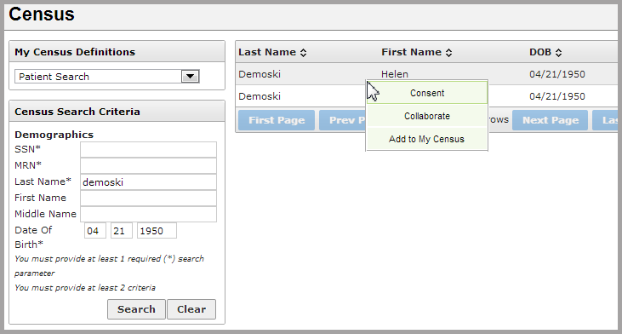

Patients matching the search criteria will appear in a list to the right of the search box. Results can be sorted by **Last Name**, **First Name**, or **DOB** (date of birth).

Click anywhere on the row with the patient’s name to access the Patient Home Screen, or right-click and choose from the menu. Clicking a tab option will take you directly the tab for that patient.

Patients previously viewed and saved are accessible by selecting **My Census** from the *My Census Definitions* dropdown box**.** To add a patient to the **My Census** menu, right-click on them in the manual search results, and choose **Add to My Census**.

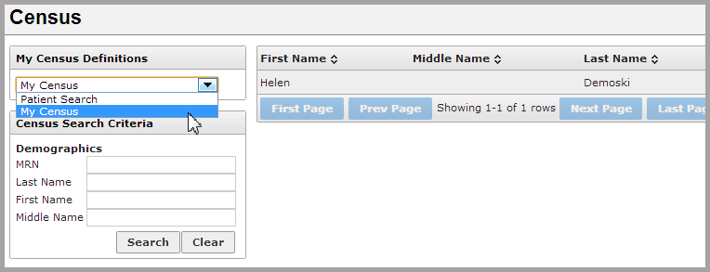

Clicking on the plus button at the right of any patient will reveal a *Switch Context Encounter* window for that particular patient. To switch contexts, select a specific encounter from the list, and click on the **Go** button at the lower right.

